PROMETEON PRESENTS THE NEW PRO CHECK, THE LATEST DIGITAL SOLUTION TO MAXIMISE FLEET EFFICIENCY THROUGH TYRE INSPECTION AND MONITORING

PRO CHECK COMBINES A BRAND NEW IN-HOUSE DEVELOPED SOFTWARE WITH THE MOST ADVANCED TECHNOLOGICAL SOLUTIONS ON THE MARKET, PROVIDING EXTRA MILE SUPPORT TO MODERN FLEETS AND DEALERS.

Milan, November 18th 2020 – Prometeon announces the official release of the new PRO CHECK, the digital monitoring solution specifically conceived to offer an easy and effective tyre management for fleets and dealers. PRO CHECK is the latest addition to the PRO SERVICES family, which combined with the wide product portfolio are pillars of Prometeon’s integrated offer. The latest technological solution from Prometeon provides a reliable and customized support to further optimize the operational efficiency of the fleets.
Care and maintenance are very important aspects to better exploit a tyres full performance and durability. However a constant monitoring of the pressure and tyre condition requires time-consuming operations and the need of professional assistance. It is well known how an incorrect pressure and worn tread can heavily affect the tyres’ performance and transport safety as a whole.

PRO CHECK is the ideal solution for both modern fleets and dealers wanting to offer a complete service. Thanks to quick and easy inspection, and constant monitoring, the new service provides detailed and interactive online information about both the vehicle and tyres conditions, while enabling removal forecast, optimized stock replenishment and price per kilometer contract management.

Prometeon’s new PRO CHECK solution is based on three important assets:
- A new and efficient inspection tool, TAP200 by Bartec Auto ID, leader in the development and production of tyre pressure monitoring systems
- A free, fast and easy to use App, connected via Bluetooth to the TAP200, available for both IOS and Android
- A new open, powerful, comprehensive, safe and extremely user-friendly web based platform with a full set of reporting, analysis and interactive functionalities

“PRO CHECK is a really valuable solution. In fact, the dealers of the Supertruck Network, who have contributed to its development through their feedback, are enthusiastic of its performance. This system will enable them to enhance their professionalism as a whole by further improving the quality of the services they will offer.” says Marco Solari, CEO Europe.

“We are proud of PRO CHECK, not only for its performances and potentialities, but also because the software behind the App and the online platform have been entirely developed by our Digital Innovations Team. This represents an important step in the path of becoming a complete tyre solutions provider. We can rely on more than 100 years of history behind us and since the very beginning Prometeon has invested a lot and built up its own Research and Development (Department), in order to keep innovating and finding new technological solutions which constitute the Prometeon Technology. These are the basis of the new products and services we can now offer our clients and partners” declares Alexandre Bregantim, Chief Technical Officer, “..with so much more to come soon”.
PRO CHECK is already available in Italy, UK, Germany, Spain, Poland and next year in other European Countries, Turkey and Brazil.

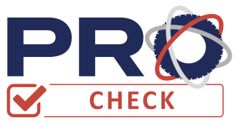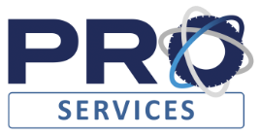

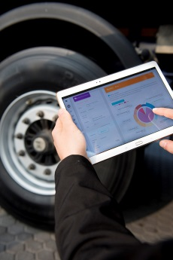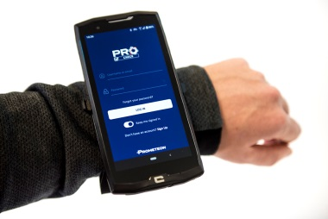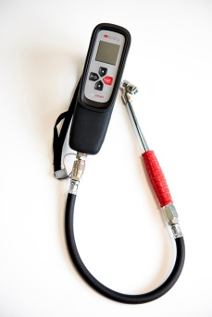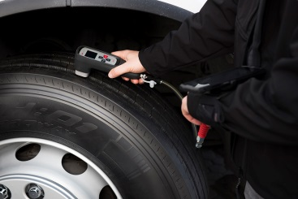

For more details visit procheck.prometeon.com

PROMETEON TYRE GROUP
Prometeon Tyre Group is the only tyre company solely focused on the Industrial sector, for the transport of goods and people, and the Agro and OTR segments. Prometeon’s is a multi-level offering with a product portfolio that includes the PIRELLI and FORMULA brands, under license, as well as the ANTEO, TEGRYS and ERACLE brands. The Group has four factories (two in Brazil, one in Egypt, one in Turkey) and three Research and Development Centers (Italy, Brazil, Turkey) and one Development Centre in Egypt which represent the heart of product innovation. The Prometeon Group has over 7,000 employees located across all five continents.

For more information:
Community Group
Pasquo Cicchini - cell. +39 345 1462429 – pasquo.cicchini@communitygroup.it
Giovanni Fabbri –cell. +39 346 3255638 – giovanni.fabbri@communitygroup.it
Edoardo Pastorino – cell. +39 337 1248485 – edoardo.pastorino@communitygroup.it

www.prometeon.com

